**Structured Hybrid Project Report – Fall 2020**

**Group Members: Vaishali Devanand (vhd2107), Abhishek Mukherjee (am5285), Harsh Tuli()**

# Introduction:

In this project, we will try to price a hybrid derivative contract paying

$$\max\left\{0,\left(\frac{S\left(T\right)}{S\left(0\right)}-k\right).\left(\left(\frac{L\left(T-Δ, T-Δ,T\right)}{L\left(0,T-Δ,T\right)}\right)-k^{'}\right)\right\},{}$$

with

* $S\left(T\right)$ the STOXX50E spot price quantoed from EUR into USD
* $L\left(t, T-Δ, T\right)$, the $Δ$ = 3-month USD LIBOR rate observed on time T between $T-Δ$ and T at time t
* $T$, the expiration date
* $k, k'$, given relative strike prices

# Assumptions:

In the given payoff above, the stock price ST is denominated in USD, so we model the stock index price process in terms of USD risk-neutral measure. Note that if the STOXX50E prices where to be quoted in EUR, then price process would simply be a geometric brownian motion in terms of EUR risk neutral measure.

We also assume that foreign interest rate (in this case EUR) is deterministic

Next,

# Methodology:

## Stochastic processes for modelling a hybrid equity index/exchange rates:

The first task here is to describe the stock price process as a GBM in terms of the USD risk neutral measure (this needs to be done as it is originally in the EUR currency). This is described the following process:

$$\frac{dS}{S}=\left(r_{f}- ρ_{sx}σ_{x}σ_{comp}\right)dt+ σ_{comp}dW^{Q^{d}}$$

where

$r_{f}$ is the foreign interest rate which is deterministic,

$ρ_{sx}$ is the correlation of STOXX50E market and USD EUR exchange rate

$σ_{x}$ is the exchange rate vol of USD EUR exchange rate

$σ_{comp}$ is the composite vol as elaborated below

$$σ_{comp}^{2}=σ_{s}^{2}+ σ_{pb}^{2}-2ρ_{s,pb} σ_{s}σ_{p}$$

## The exchange rate process is given by below:

$$\frac{dX}{X}=α_{x} dt+σ_{x} dW_{c}$$

We model USD-3month LIBOR short rate either using Vasicek or 2-factor Hull-White model:

## Vasicek model:

$$dr_{t}=a\left(b-r_{t}\right)dt+σd{W^{Q}}^{d}$$

## 2 – factor Hull-White model:

$$dr_{t}=(θ_{t}-br_{t})dt+σd{W^{Q}}^{d}$$

The Hull-white model has a structure similar to Vacisek model but the difference is that $b_{t}$ is time-dependent variable in the Hull-White model to make it fit the current term structure.

# Model calibration and Simulation:

## Equity/FX model:

We use historical data of EUR/USD rates and STOXX50E prices to calibrate the equity/FX model

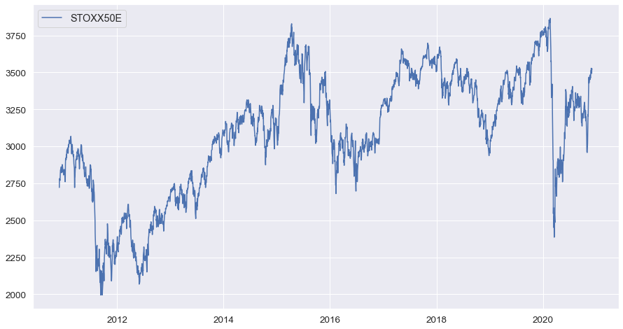

Simulated paths of STOXX50E from GBM model:

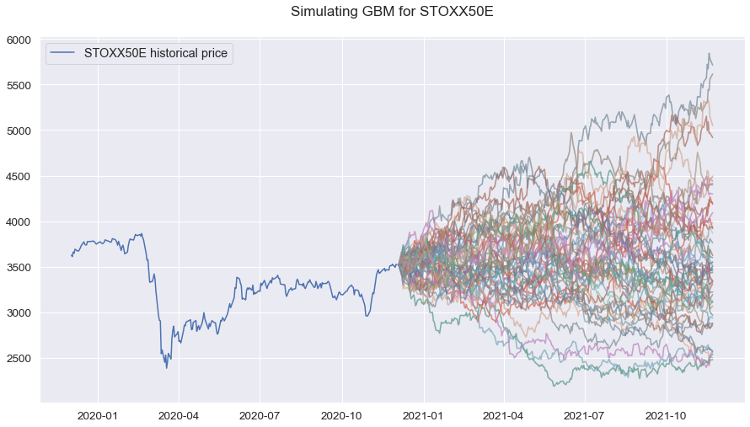

## Rates model:

Vasicek model:

Below is the chart of historical USD 3-month LIBOR rates:

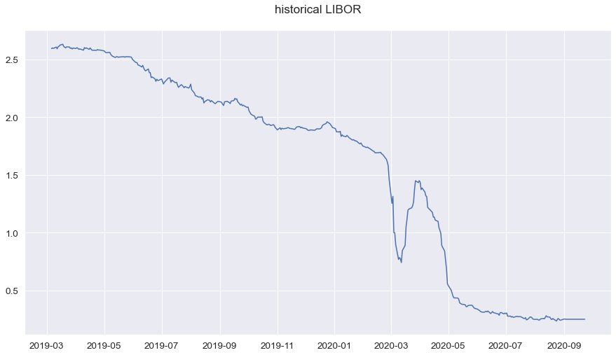

Simulated 3-month USD LIBOR rates:

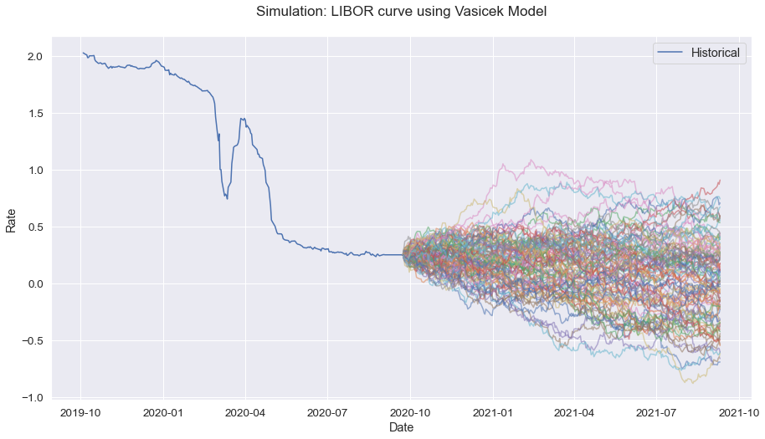

For Hull-White model, the following equations get the closed-form solution of $θ_{T }$



$σ_{p}$ can be determined by the following calibration since we have the historical caplet prices $c(t,T,K,S)$

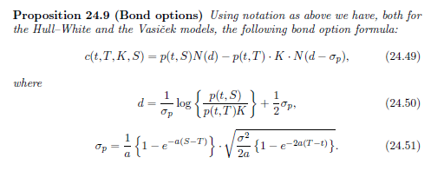

Now, the bond prices can be determined by the following affine rate model:

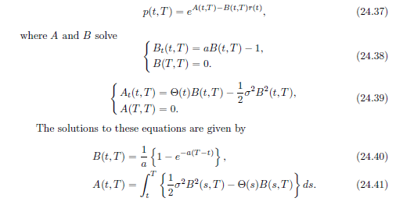

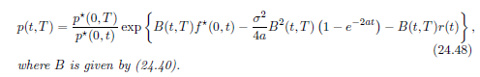

Now that we have the bond prices, we can derive the LIBOR rates as follows:

$$L\left(t,T,T+Δ\right)=\left[P\left(t,T\right)-P\left(t,T+Δ\right)\right]/[Δ*P\left(t,T+Δ\right)]$$

# Conclusion:

Finally, we run Monte Carlo simulation of $S(T),$ $L(T-Δ, T-Δ, T)$ to obtain price $p$ at time $t= 0$ of the derivative contract which is given by

$$p = E[exp\left(-rT\right)*\max\left\{0,\left(\frac{S\left(T\right)}{S\left(0\right)}-k\right).\left(\left(\frac{L\left(T-Δ, T-Δ,T\right)}{L\left(0,T-Δ,T\right)}\right)-k^{'}\right)\right\}]$$

Now the pricing engine takes the following inputs from the user to output $p$

1. $S(0)$, current Stoxx50E price quoted in USD
2. $T$, $k,k'$, time to expiration and relative strike prices respectively
3. $L\left(0,T-Δ,T\right)$, current forward USD-Libor 3m rate between $T-Δ$ and $T$